**ARFOR PROGRAMME**

**Grants to Support the Use of the**

**Welsh Language in Business on Anglesey**

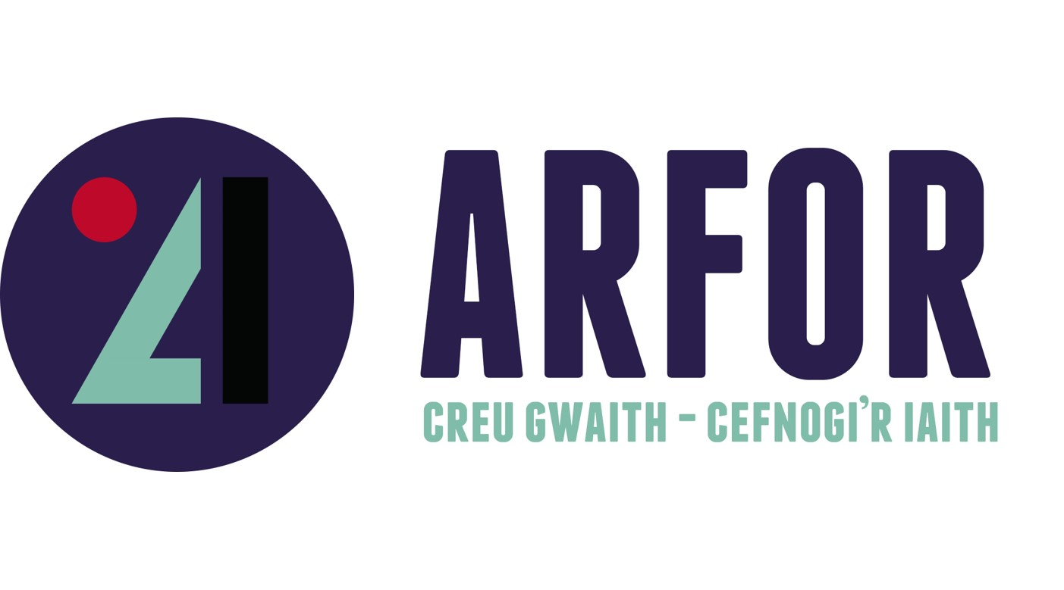

Llun yn cynnwys testun, celf clipio, logo, gwaith graffig

Wedi cynhyrchu’r disgrifiad yn awtomatig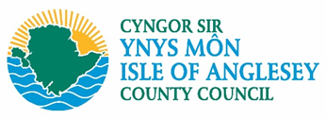

**Application Form**

***Updated 28/6/24***

**GRANT APPLICATION FORM FOR ISLE OF ANGLESEY**

**Part 1 – Beneficiary Form / General Information**(Relevant for the Isle of Anglesey Language grant)

1.1 Name and address

the business

1.2 Is the business

about to be established?

Already operating?   
  
1.3 In what year was the business established / trading started?   
  
1.4 Type of business (eg sole trader / company etc)?

1.5 Briefly describe the main activities of your business

1.6 Does the business have a bank account in its name that requires the signature of 2 people to authorize payment? Yes No I don’t

1.7 Can the business claim VAT back? Yes No

VAT number:

1.8 Registration Number (if applicable)

1.9 Relevant contact details   
  
Name of main contact:   
  
Position within the business:

Phone number:

Email:

**Part 2 – ARFOR Welsh Language Grant Application Form Isle of Anglesey**

|  |  |  |  |  |  |  |
| --- | --- | --- | --- | --- | --- | --- |
| 2.1 Outline the purpose for which this grant will be used? State here any events / changes / improvements / resources that will be funded through the grant.    Gjvuguguug  2.2 State your aspirations for how you would like to see the business use more Welsh?  2.3 What do you think are the benefits to your business of doing this and how does it fit into your wider business plan?  2.4 Project costs and funding request?  Maximum grant of £2,000  A minimum 30% matching cash contribution required   |  |  | | --- | --- | | Total expenditure? |  | | Application for Language grant funding? |  | | Your match funding contribution? |  |   2. 5 Give details below, item by item, of the expenditure you need help towards** |
|  |

|  |  |  |  |  |
| --- | --- | --- | --- | --- |
| Capital / revenue items | Suppliers | Cost  (excl. VAT) | Cost  (with VAT) |  |
|  |  |  |  |  |
| TOTAL EXPENDITURE | |  |  |  |

** Any equipment or service purchased must be competitively priced. See the guidelines for tendering. A single purchase worth less than £50 cannot be included.

|  |  |  |  |  |  |
| --- | --- | --- | --- | --- | --- |
| **Timing of Language Grant Project Expenditure** | September 24 | October 24 | November 24 | December 24 | Total |
| Project Expenditure | £ |  |  |  | £ |
| ARFOR Grant to be Claimed | £ |  |  |  | £ |

2.6 Has your business received any grant of public money in the last 3 years?

Yes. If you have received such money, we will need to know. You will need to sign the De- Minimis aid declaration form.

No

**Applicant Statement for ARFOR Language Grant Application:**

I confirm that the business has discussed this application with a Menter Môn staff member in advance to submit it.

I confirm on behalf of the business submitting this application that I have the authority to sign this statement and that all the information on this form, as far as I know, is correct.

I understand that if the Arfor Language grant is agreed, the grant will have to be spent in accordance with the conditions and terms of the offer, and if the conditions are not adhered to it is possible that repayment will have to be made the grant either in part or in full.

Name:………………………………..................................

Position in the Business: ............................................ ............

Signature…………………………….. Date:.................

**NOTE: The** language project should not start until you have received, and signed, a formal grant offer from Menter Môn or Anglesey County Council.

***Data Protection Act 1998*** *: For the purposes of the Act, Anglesey County Council controls the data. However, in this case the data is processed by Menter Môn on behalf of the Council. The information on this form is used for the purpose of administering grants and subsidies. It is possible that it will be disclosed to other agencies in accordance with the Council's registration under the Act and to the Welsh Government in accordance with the administration of Arfor schemes.*

*As a public authority, Anglesey County Council is subject to the requirements of the Freedom of Information Act 2000.*

**HELP NOTES TO APPLY**

**ARFOR Language Fund**

Note that it is possible to apply for a maximum grant of £2,000 at a rate of up to 70% (i.e. each applicant is expected to be able to contribute at least 30% of the total cost of the project, but this can be on a general business investment without a linguistic element). We can consider requests in excess of £2,000 in special cases.

3.1 It is required that any business / group applying for support through   
the Arfor Language fund completes a Welsh language self-assessment questionnaire - more information here [Self Assessment Questionnaire - Welsh Language Development Plan](https://forms.office.com/pages/responsepage.aspx?id=gXJ5PfHSYEqkGsc-ufeod2Bxn0BDOMtAq0xqqPp2_6pURVo4UFlNMjVLOEQ4SEhLTzNPWEg2TlJMMS4u)

3.2 State your aspirations for how you would like to see the business use more   
Welsh and how you hope to maintain this use within your business.

3.3 When referring to the benefits, attention should be paid to the impact that can be made for you as a business and the local economy.

3.4 You are asked to follow the guidelines for inviting quotations when seeking prices for   
the project and include all evidence with your application.

3.5 You are asked to enter the details of each item that will be purchased with the support of the grant. A single purchase worth less than £50 cannot be supported.

3.6 You are asked to indicate which items of expenditure are revenue costs and which items of   
expenditure are capital costs. All quotes can be verified for authenticity

There is a separate form for showing the quotations / separation tenders, which you have received.